Vocabulary N° 4
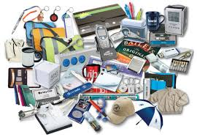
Means of Transportation

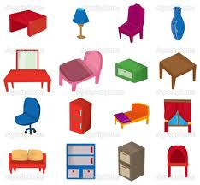
Means of transportation allow people to travel. They can also transport merchandise
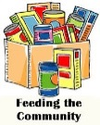
goods and furniture

Means of transportation are divided into:
by land, by sea and by air.

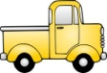
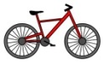
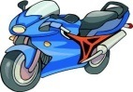
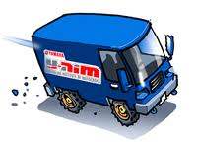
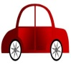
By land: car van motorcycle bike lorry
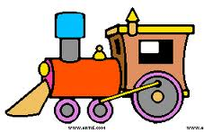
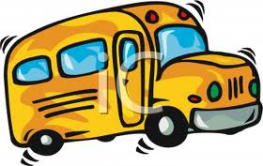
bus train

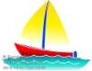
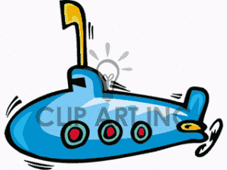
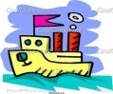
By sea: ship boat submarine
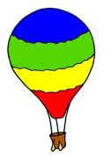
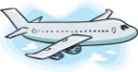
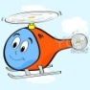
By air: airplane helicopter hot air balloon

